To edit the shape of the OML:

(To move points forward or backward)

1. Turn on (right click on a sketch and select “show”/eyeball icon) all the Side Sketches

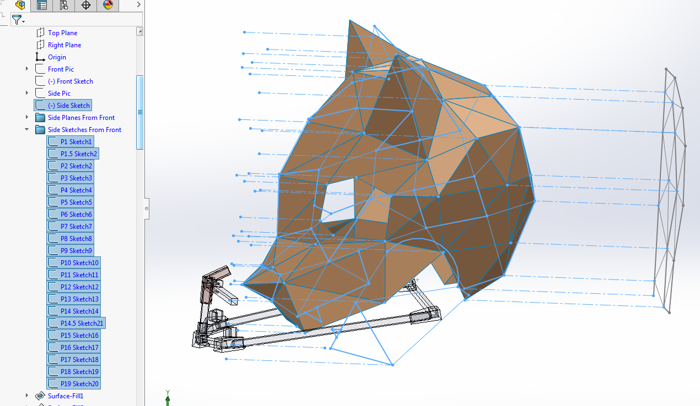

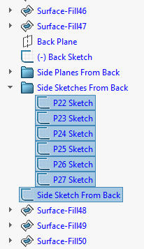

1. Click on the construction (dashed) line that points to the vertex you want to move to select it. Right click on the line and select the upper left icon for edit sketch.

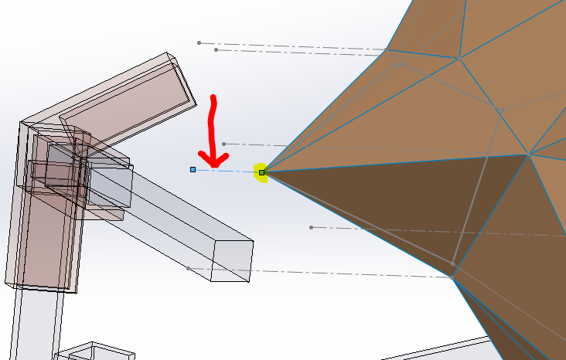

1. Left click and hold on the vertex you want to move. Drag it to the new location and release. Click exit sketch and the surfaces will update.

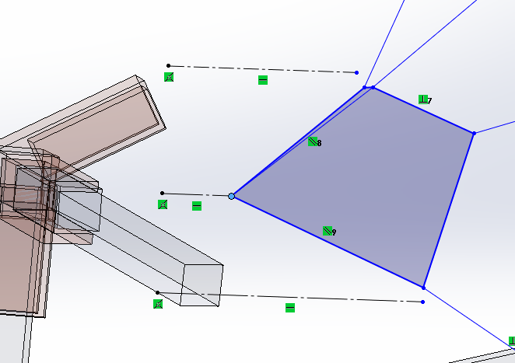->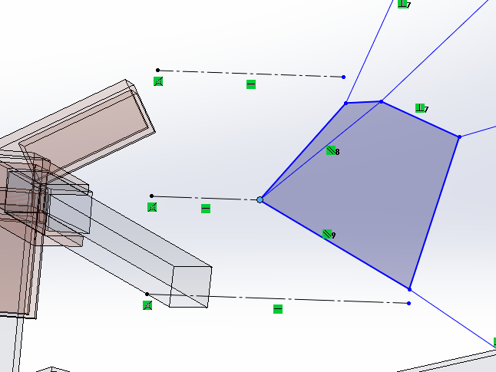

(To move points up/down and left/right)

1. Turn on/show the “Front Sketch” and “Back Sketch”

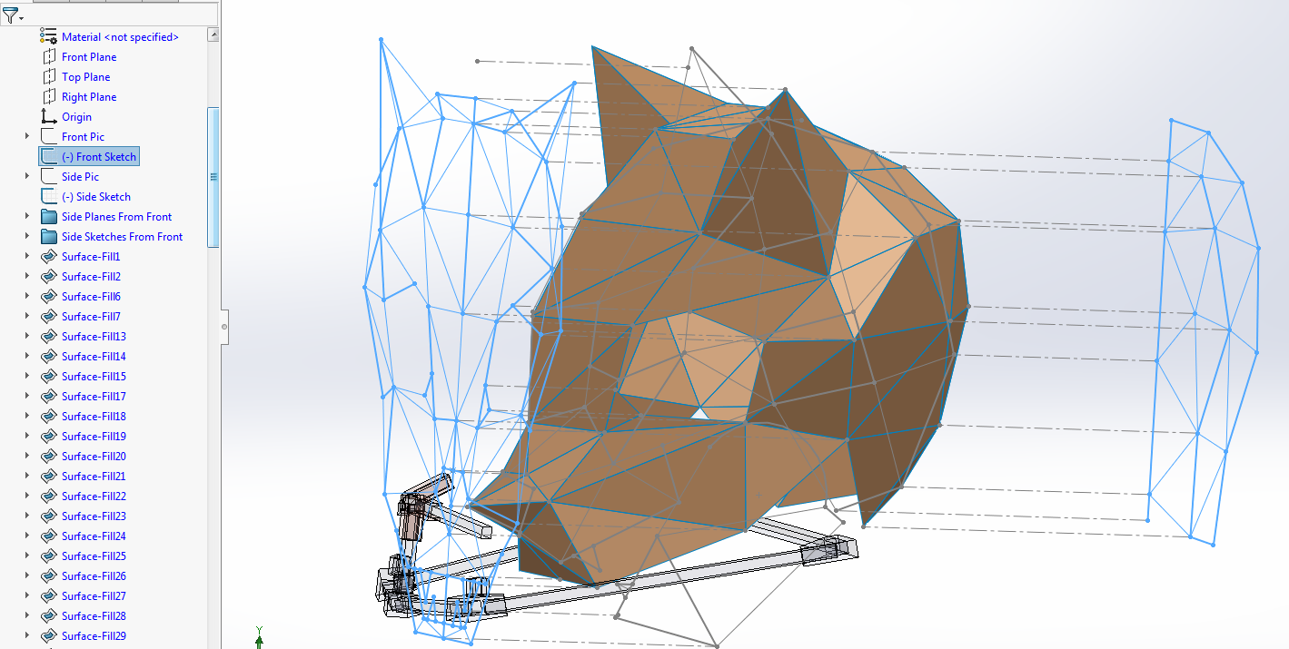

1. Right click on a line in either the front or back sketch (the one you want to edit) and click “edit sketch”

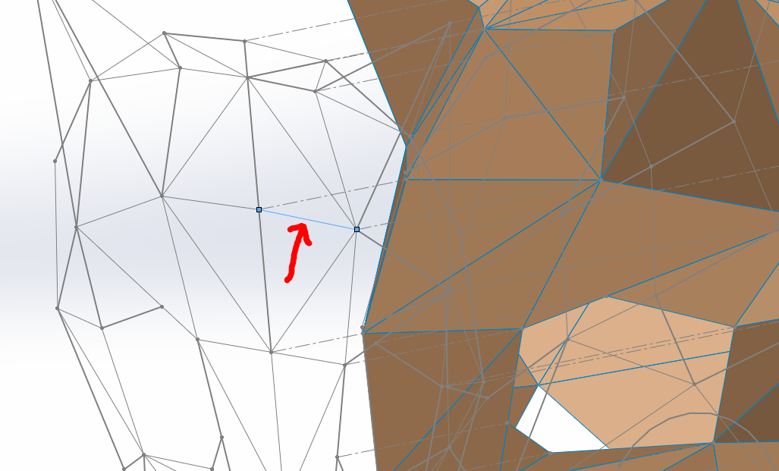

1. Hold Control on the keyboard (this will stop the point from snapping to automatic locations) and then Left click and hold on the vertex you want to move up/down and/or left/right, drag it to the new location and release. Exit the sketch. All of the side sketches will update.

